Ideation Phase
Empathize & Discover

Date | 18 January 2025
Team ID | LTVIP2026TMIDS24884
Project Name | Heart Disease Analysis
Maximum Marks | 4 Marks

Empathy Map Canvas:
An empathy map helps us understand the needs, concerns, and behaviors of users interacting with heart disease data. For this project, we identified three key user groups:
- Cardiologist
- Government Health Officer
- Individual Patient
Below is the empathy map focused on the Primary User: Cardiologist.
Example:
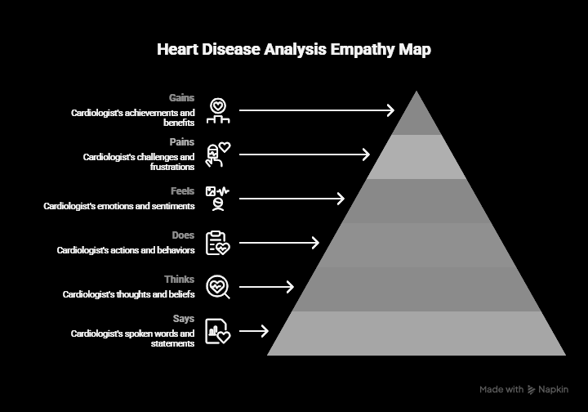

Reference: https://www.mural.co/templates/empathy-map-canvas

